There is a long and thin painting that can be represented by a number line. You are given a **0-indexed** 2D integer array paint of length n, where paint[i] = [starti, endi]. This means that on the ith day you need to paint the area **between** starti and endi.

Painting the same area multiple times will create an uneven painting so you only want to paint each area of the painting at most **once**.

Return *an integer array* worklog *of length* n*, where* worklog[i] *is the amount of* ***new*** *area that you painted on the* ith *day.*

**Example 1:**

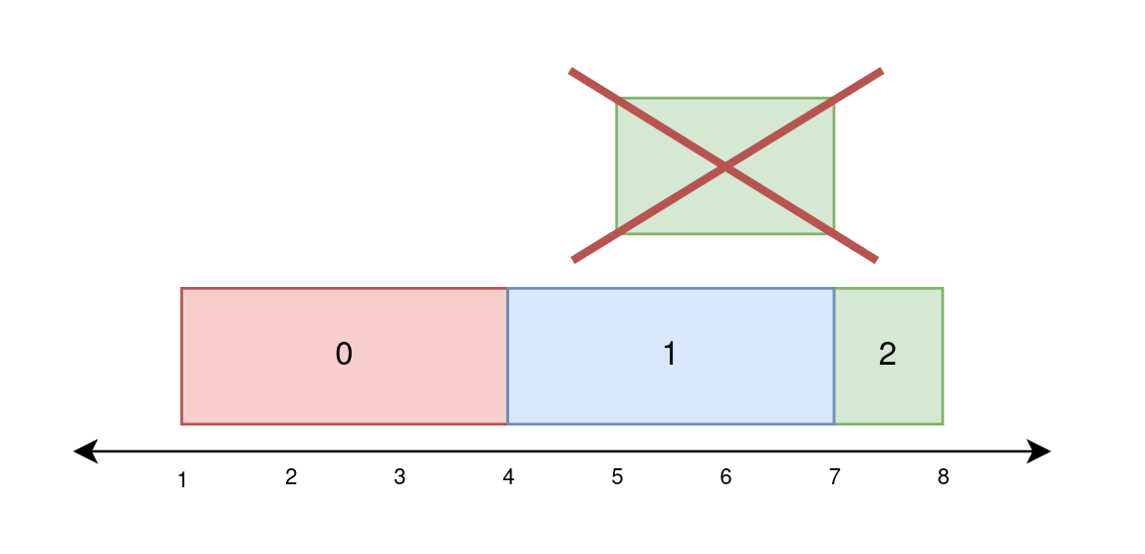

Input: paint = [[1,4],[4,7],[5,8]]  
Output: [3,3,1]  
Explanation:  
On day 0, paint everything between 1 and 4.  
The amount of new area painted on day 0 is 4 - 1 = 3.  
On day 1, paint everything between 4 and 7.  
The amount of new area painted on day 1 is 7 - 4 = 3.  
On day 2, paint everything between 7 and 8.  
Everything between 5 and 7 was already painted on day 1.  
The amount of new area painted on day 2 is 8 - 7 = 1.

**Example 2:**

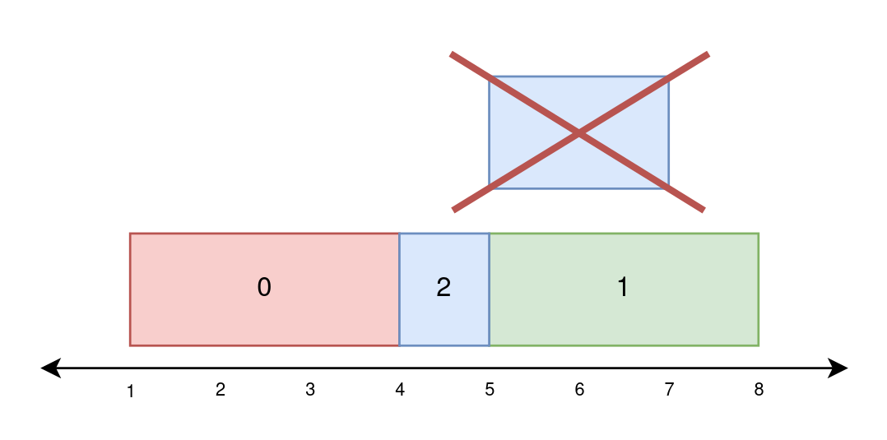

Input: paint = [[1,4],[5,8],[4,7]]  
Output: [3,3,1]  
Explanation:  
On day 0, paint everything between 1 and 4.  
The amount of new area painted on day 0 is 4 - 1 = 3.  
On day 1, paint everything between 5 and 8.  
The amount of new area painted on day 1 is 8 - 5 = 3.  
On day 2, paint everything between 4 and 5.  
Everything between 5 and 7 was already painted on day 1.  
The amount of new area painted on day 2 is 5 - 4 = 1.

**Example 3:**

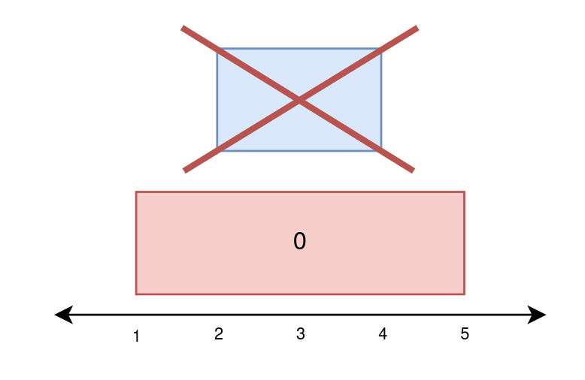

Input: paint = [[1,5],[2,4]]  
Output: [4,0]  
Explanation:  
On day 0, paint everything between 1 and 5.  
The amount of new area painted on day 0 is 5 - 1 = 4.  
On day 1, paint nothing because everything between 2 and 4 was already painted on day 0.  
The amount of new area painted on day 1 is 0.

**Constraints:**

* 1 <= paint.length <= 105
* paint[i].length == 2
* 0 <= starti < endi <= 5 * 104